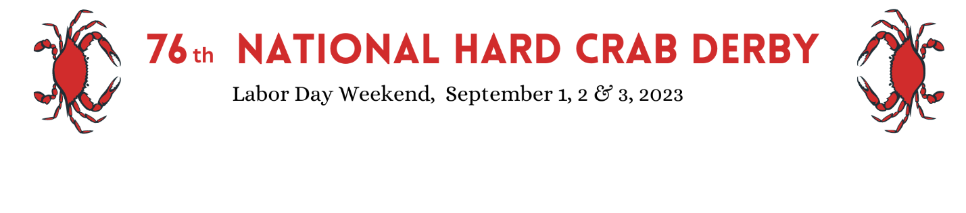
59th Annual Crab Cooking Contest Application
Contest Date- Friday, September 2, 2022
PO Box 292 410-968-2500 Crisfield, MD 21817 1-800-782-3913
www.crisfieldchamber.com
1. Recipes should be original and never published in any public forum.
2. Maryland Blue Crab Meat must be the predominant ingredient in the recipe. Additional ingredients such as meat or cheese should not obscure the flavor and texture of the crab meat.
3. Please do not use a person’s name in the title of the recipe.
4. Finalists will provide all recipe ingredients as well as mixing bowls and cooking utensils. The National Hard Crab Derby will supply 1 pound of fresh special grade Maryland Blue Crab Meat. Ingredients may be pre-cut or premeasured, but the recipe must be prepared on site.
5. A contestant may submit a recipe in two of the four divisions: Main Dish, Crab Cakes, Appetizers, and Soup/Salad. If space permits, the contestant will be allowed to prepare both recipes.
6. A copy of the recipe, including full ingredients and instructions, must be submitted. Please print name, address, phone number, and the cooking division on the recipe.
7. Applications and recipes must be submitted no later than August 26, 2022. If there are more entries in each category than can be properly accommodated, finalists will be chosen according to the date of their submitted applications. Please send in your applications early.
8. Participants will be personally notified via phone call or email that their recipes have been selected. An entry fee of $25.00 can be paid by mail or at the registration table on the morning of the contest.
9. Judging will be based on: the appropriate use of crab, appearance, flavor, originality, texture, clear directions, ease of preparation and serving, and presentation. The judges emphasize presentation as an important component.
10. Recipe entries constitute permission to edit, modify, adapt, publish, promote, and otherwise use the recipe in any way without additional compensation.

